Title IX Resources and Referrals
South Arkansas College
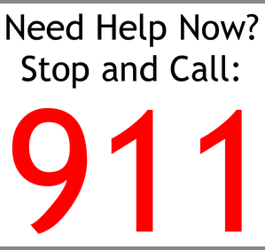  Emergency Services  On Campus  870-864-7125 (West)  870-310-5788 (East)  870-665-1908 (East after hours)  999 from Campus Phone  for Campus Security  for El Dorado Police  - Red phones in each campus building will connect with Campus Security.  - Blue phones in campus parking lots will connect with El Dorado Police Department | Medical Assistance  In the event of sexual assault, contact  South Arkansas Regional Hospital  870-863-2000  - Victims can go to South Arkansas Regional Hospital or their local hospital for medical services. A victim should not wash in any way until he or she has been examined.  - A police report is not required to receive medical assistance. | CONFIDENTIAL RESOURCES  Turning Point  870-862-3672  870-862-0929 (24/7)  Women’s Crisis Center of South Arkansas  870-836-0375  870-836-0325 (24⁄7)  New Haven Counseling and Health Services  870-862-7921  Living Water  870-235-1414 (24⁄7) | Academic Accommodations  for Students  Title IX Coordinator  Vanessa Williams  870-875-7235  Work accommodations for employees will be handled in conjunction with Human Resources (870-864-7146).  - The Title IX Coordinator assists with academic and work accommodations and referrals, and oversees Title IX investigations.  - Counseling is available to all parties involved in a Title IX case.  - National Sexual Assault Hotline  1-800-656-HOPE

