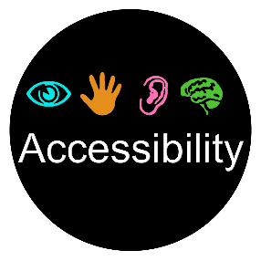
ADA Resources Available to SouthArk Students

General Accommodations
- Test proctoring
- Extended time on tests
- Testing in a quiet environment
- Excused absences
- Brief breaks from class
- Preferential seating
- Extended time on assignments
- Note taking
- Tape recorded lectures
- Bookshare (PDF copies of texts for the blind)
- Dragon software
- Special pen and paper for note taking (Echo pen)
- Scholarship through the SouthArk Foundation
- Partnership with Arkansas Department of Career Education and Arkansas Support Services as well as Division for the Blind
- JAWS screen reader software

Facilities Accommodations
- Handicap accessible restrooms
- Door assists for entrance to campus buildings
- Wheel chair accessible buildings
- Wheel chair accessible sidewalks
- Appropriate crosswalks
- Accessible computer stations in classrooms, library, and Testing and Learning Center

