Faculty Affairs Minutes
August 25, 2016
Present: Ken Bridges, Linda Bates, Henry Culbreth, Ralph Phillips, Susan Spicher, Rhonda Lee-Ernest, Roslyn Turner, Vicki Badgley, Lisa Lewis, Karen Boykin, John Spencer, Michael Champion, Nancy Whitmore, and Jennifer Parks
The next meeting will be Thursday, August 1, 2016 at 4 pm in room 209 whitfield building.
Issues of concern to faculty at Southark which could possibly be agenda items after the committee structure proposal is finished:
Blackboard classes have a cap of 30. This number was appointed at some time and was not approved by the Distance Learning committee.
Please remember to follow up with the Professional Development Committees review of each session held at convocation. You feedback regarding each break out session is important.
Communication from the Planning council have been less than satisfactory. What does the Planning council do? Is it supposed to disseminate information? What is its makeup? How and who is supposed to communicate to faculty?
There were many sick leave questions and it is clear that between divisions, the same policy for sick leave is not being used. For part of a day or for working at home even though a sick day has been taken, the policy is not clear.
The purpose of this meeting is to discuss and develop a proposal for the committee structure at Southark. Attached to the minutes are the expired committee chairs list from the office of the VPL.
The following were agreed upon by the members of the Faculty Affairs committee present:
Each member may serve up to 6 years on one committee.
The secretary of each committee will be elected among the committee members. The secretary will take the minutes and send them to the committee members for approval. Upon approval, the chair of the committee will have the approved minutes posted on the appropriate section of the Southark webpage.
Leadership rotation will proceed from Vice-Chair then to Chair. The Chair of the committee must have served as Vice-chair for at least one year.
Determining who is a member of each committee has not been decided. More than one proposal has been presented and discussed. None have been finalized and will not be final until voted on by the faculty. For consideration of this faculty Affairs committee and all Faculty who are present:
As a method of organizing and populating the standing committees at Southark:

Establish a Committee on Committees (or a committee called a Nominating Committee)

Purpose
The purpose of the C on C is to focus only on membership of standing college committees, Student Services Committee, Academic Standards Committee, Assessment Committee, Professional Development Committee, and the Library Committee. Faculty Affairs, will remain the same for the next year to complete this process.
Charge
The C on C is a standing committee charged with over site of all standing committees. This committee will oversee the appointment of all committees’ members. As the duties for this committee are reviewed, they may also come to include seeing that minutes or notes are provided and placed on the Intranet site for easy access and updated regularly, reporting progress, challenges, and issues to the VPL.
Members:
Members of the C on C will be the VP for Learning, VP for Student Affairs, two members from Faculty Senate chosen by the Chair of the Faculty Senate, two members from Student Services chosen by the VP for Student Services.
Committee composition

1. The members of the Committee on Committees will be the VP for Learning, VP for Student Affairs, two members from the Faculty Senate, the Chair and Vice-Chair and two members from Student Affairs chosen by the VP for SA.
2. Division or department representation should be appropriate to the role and scope of the committee. If faculty representation is needed, divisions should be represented equitably. As the college organization of divisions has been revised frequently, the C on C will monitor and suggest revisions to be approved by all committees of Southark.
3. With ex-officio approval and committee support, committees may permit any interested faculty and staff to join. These members will be listed as "members at large" in the membership list and will be places on a 3-year rotation; members-at-large will have voting privileges for the 3-year rotation.
4. Any changes on committee positions or membership should be forwarded to the CoC so the college membership list may be updated.
a. At the beginning of each school year all full-time faculty will present to the VP for Instructional Activities three choices for committee for which they wish to participate.
b. By the end of the first week of school, the VP for Instructional Activities and the Nominating Committee chosen by Faculty Affairs committee will go over the recommendations and place faculty on their desired committee.
c. Each Committee will elect a chair and a secretary from their membership for the school year.
d. Committee membership will be staggered with alternating 2-year and 3-year terms so that all memberships are not up for re-nomination each year.

2016-2019 2019-2022 2022-2025
_________________ _________________ __________________
_________________ _________________ __________________
_________________ _________________ __________________
_________________ _________________ __________________
_________________ _________________ __________________
________________ _________________ __________________
_________________ _________________ __________________

Committee roles and responsibilities -- we already have this in our APM, see page 24, the only addition is that of the Vice Chair or Chair elect.
Chair and Vice-Chair will be elected by the committee members at the first meeting at convocation each year. Chairs will serve one-year terms. Vice-Chairs will serve as Chair-elect and will be the chair the following year.
The Chair and Vice-Chair (Chair-Elect) the Chair of the Committee will schedule meetings and communicate all committee matters. The Vice Chair will assist in all functions as requested by the chair. The following are duties for the Chair: Lead in accomplishing the charge of the committee, Arranges and conducts meetings, prepares agendas, gives members assignments and sub-committee work, Encourages participation from all members, Reports changes or suggestions for the committee to the Committee on Committees, Reports the committee activity to the Ex-Officio as necessary, Reviews minutes and reports for the accuracy, prior to posting, and Fills open positions with help from CoC and Deans.

- Recorder (Secretary)
Maintains minutes of all meetings
Distributes the approved minutes to the Chair who will distribute them and any action items for all meetings within five business days after the meeting to members of the committee and to the VP for Learning or Student Affairs, whichever is appriopriate.

- Member (appointed or volunteers)
Presents, clarifies, and otherwise participates as an active committee member.

Posting Minutes
- Minutes will be approved by each committee in a timely fashion. Then minutes are forwarded to the Chair of the committee by the secretary. The Chair or whomever is appointed by the chair will forward the approved minutes to the VP for Learning or the VP for Students Affairs who will be responsible for posting the minutes on the appropriate drive and location on the Southark website.

Rotation
- Members: As a general guideline, standing committee members will rotate off their committee (or renew their commitment) after three (3) years. For the sake of continuity, only one third of the membership will rotate off each year. The committee on committees (CoC) will coordinate the rotation process.
  - Exceptions: Because of the nature of their charge, some committees may need certain positions represented permanently. The effectiveness of the committee may be enhanced by having rotation cycle of more or less than the standard 3 years.
  - Communication: Each committee chair, with ex-officio consultation, and any appropriate input from members, shall report exceptions for position rotation and/or length of the rotation cycle to the CoC. Any exception forwarded to the CoC should be accompanied by a brief rationale. The CoC will incorporate these exceptions into the rotation scheme for each committee. The rotation exception will be noted along with purpose, charge, and membership records.
- Chairs: As a general guideline, standing committee members will rotate off their committee after three (3) years. The committee on committees (CoC) may suggest adjustments to maintain continuity.
  - Chair-elect: To improve rotation of committee members and faculty governance, the chair-elect Will assume the duties of the chair of the committee after serving one year as vice-chair or chair-elect. The chair will be moved to another committee as a member by the CoC.
  - Communication: Committee chairs, with ex-officio approval, shall report exceptions for position rotation and/or length of the rotation cycle to the CoC. Any exceptions forwarded to the CoC should be accompanied by a brief rationale. The CoC will incorporate these exceptions into the rotation scheme for each committee along with purpose, charge, and membership.

Replacing inactive members
- After consultation with the committee chair, members who miss 3 consecutive meetings without a legitimate conflict may be replaced.
- Members who have meeting-time conflicts can arrange for a temporary substitute to represent their department.
- Members who have meeting-time conflicts can remain active by participation and work completed outside of the meeting time
- If there is a consistent conflict related to job duties, the meeting time should be altered or another representative selected from the appropriate unit
- If removing an inactive member becomes necessary, chairs will work with the appropriate academic dean or department supervisor to identify a replacement.
Incorporating new employees and identifying faculty/staff with the interest in specific committees
- Each faculty/staff member is encouraged to communicate their interest in specific standing committees with their supervisor. For new employees, this conversation may occur at the conclusion of the probation period or during the first annual evaluation.
- CoC will conduct a survey of faculty and staff interest in specific committees by asking for their top three preferences for committee work each fall convocation.
- The interest inventory will serve as a resource to committee chairs and supervisors as they fill vacancies on committees.
- With approval of the members of the C on C and committee support, committees may permit any interested faculty and staff to join. These members will be listed as "members at large" in the membership list and will be placed on a 3-year rotation; members-at-large will have voting privileges for the 3-year rotation.

Process for staffing communicating committee membership annually
- Chairs will review the membership with their ex-officio member and communicate membership at the end of spring with the C on C.
- Chairs will work with the appropriate academic dean or departmental director to fill and vacant slots due to individuals rotating off the committee or resigning from the committee
On page 24 of the APM: 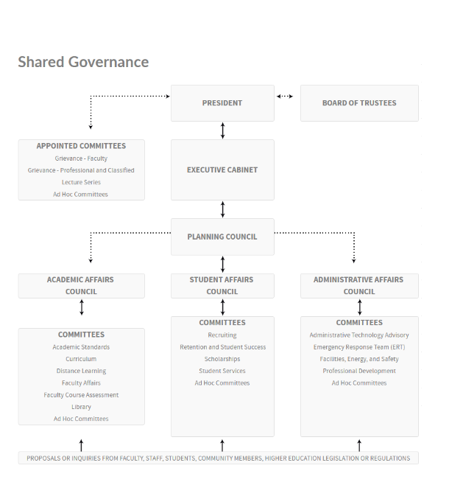
To be revised so that Faculty Senate is also a reporting body to the Planning Committee.

Proposed shared Governance
