

One of the most sincere forms of respect is actually listening to what another has to say.

Bryant H. McGill

**Our Services**

* Personal Counseling

We want every student at SouthArk not only to succeed, but also to excel.

Many of our students are pursuing their education while also supporting families and holding down jobs. With the pressures our students face, it’s no surprise that stress levels may become difficult to manage. This is where the counselor can help.

**Examples of Documentation:**

* **IEP or 504 from high school**
* **Psychiatric Evaluation**
* **Medical Records**
* **Letter from a doctor or a licensed therapist/psychologist**

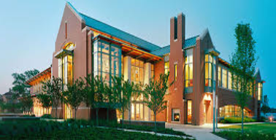

**Counseling**

**Our Mission**

The principal goal of SouthArk’s counseling program is to empower students to have successful and fulfilling careers in a field appropriate to their individual strengths and interests. The counselor helps students set reasonable and appropriate goals and present themselves in a manner that will maximize their strengths.

SouthArk’s counseling department promotes an environment that values diversity both in a college setting and the community at large. The counseling program strives to help students maximize their full potential while taking proactive steps to live healthy emotionally, spiritually, and physically.

**Disability Support Services**

**Our Mission**

The mission of the DSS is to create an accessible, inclusive, sustainable learning environment, where disability is recognized as an aspect of diversity that is integral to the campus community and to society. Through collaboration and support of the entire campus community, we will strive for equal educational opportunities for individuals with disabilities.

**Core Values**

* Human variation is natural and vital in the development of dynamic communities.
* Disability is a social/political concept that includes people with a variety of conditions who share common experiences.
* Inclusion and full participation are matters of social justice.
* Creating usable, equitable, sustainable, and inclusive environments is a shared responsibility.

Go. Grow. Graduate.

SouthArk is a college that cares about its students. We want to see every student go, grow, and graduate. Student Services supports students in several different ways, including offering services for individuals with disabilities and offering personal counseling free of charge to its students.

* Receive accommodations in order to reduce environmental and learning barriers in the classroom and on campus
* Receive information regarding disability resources, advocacy, and accommodations.
* Receive help with handling stress, depression, and anxiety, as well as other emotional concerns

www.southark.edu

**SouthArk Student Services**

**Why Counseling?**

**Making Contact**

1. Visit the Library, room 138

**Or**

1. Call the Director of Counseling & Disability Support Services, **Vanessa Williams at**

**870-875-7235.**

**Or**

1. Email counseling@southark.edu



**South Arkansas**

**Community College**

**300 Summit Ave., El Dorado, AR 71730**

**SouthArk Library, Room 138**



Counseling & Disability Support Services

NATIONAL EMERGENCY GRANT-ARKANSAS SECTOR PARTNERSHIP

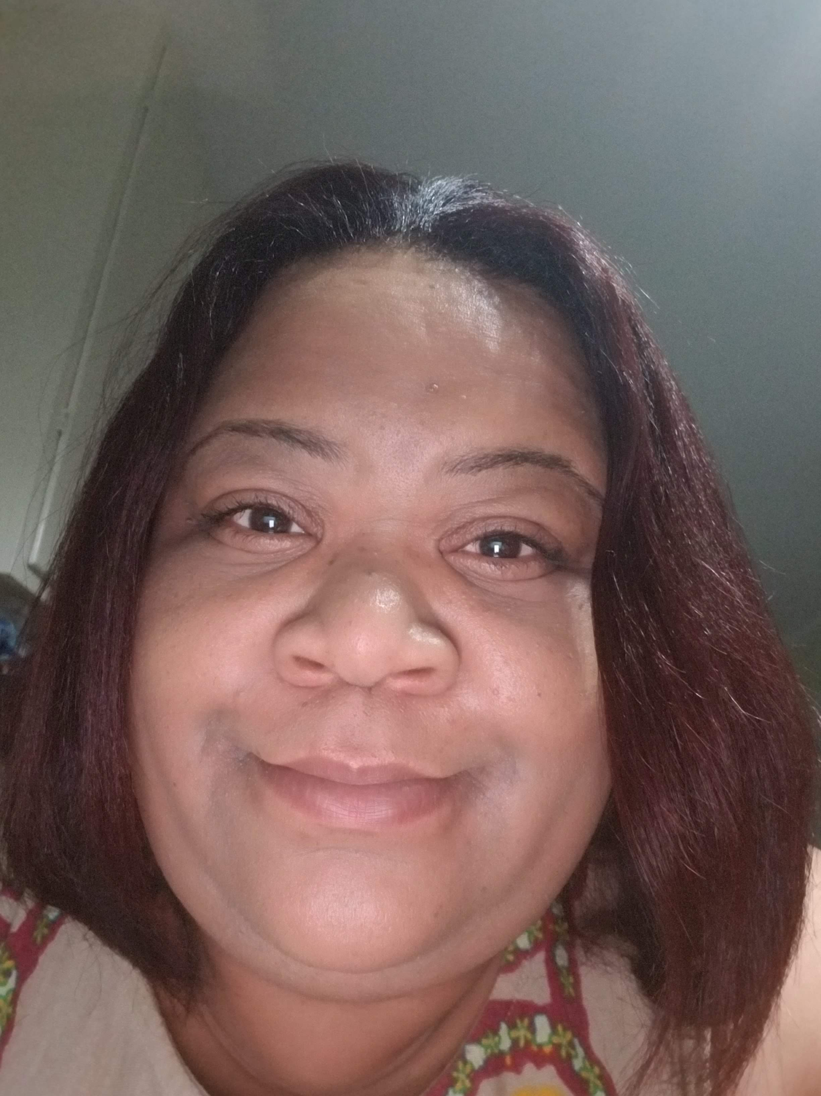



We conclude that in the field of education, the doctrine of “separate but equal” has no place. Earl Warren

To be eligible for accommodations, the individual must be a SouthArk student and must have a disability.

Students will be asked to provide documentation that describes their disability and its likely impact on educational experiences. If no disability documentation exists, students are encouraged to meet with a DSS staff member to discuss options for assessing potential academic barriers and how it relates to the student's disability.

The college experience can be challenging to students. The counselor can help students face these challenges in a compassionate, caring way.

**Typical Reasons to Seek Counseling**

* Test anxiety
* Relationship Challenges
* Poor Communication
* Depression

Students may also be referred to the counselor through the behavioral review process, following a complaint or concern for a student’s well-being. Students can be referred non-formally by faculty or staff by phone for issues that do not pose a serious threat to the student or others. The counselor will then contact the student to set up an appointment. Students can make an appointment on their own for services.

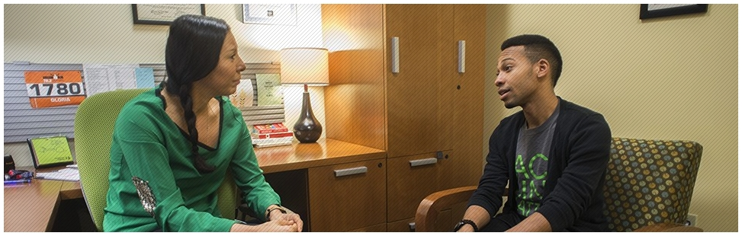

**Are you Eligible for Disability Support?**